Minnesotans Speak Their Broadband Truth:
Testimonials about the Need for Broadband

RURAL NEED
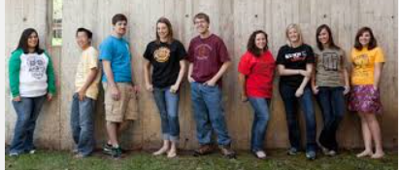

"We're not unimportant people; we should have some sort of access." - resident in Morris http://wp.me/p3if7-3ch

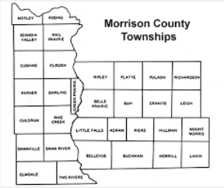
"It is extremely important that the people who live in rural MN have just the same sort of access as those who live in town. It's hard to do Township work without broadband. People want to move to our area, but can't because of the lack of Internet service."
Patty Bauchard Ripley Township http://wp.me/p3if7-3gR

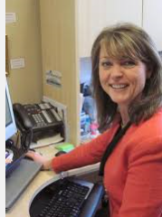
"The broadband was so poor, I couldn't update software on my computer. The service technicians had to take my computer to another location to download Microsoft Office." Jean Spaulding, Willmar http://wp.me/p3if7-3gR

"We've got fiber running across the field, we've been trying to get a permit to get that over the highway to us. The provider on one side of the highway offers 100 Mbps; the provider on the other side offers 1.5 Mbps." San Romain, Haug Kubota, Willmar http://wp.me/p3if7-3gz

"Lack of broadband is hurting our youth hockey! Prospective parent volunteers aren't able to do the necessary online training to get approved to be coaches. The organizers in the cities don't understand it's not a matter of being too cheap to upgrade our home connections - there are no options for an upgrade!" Traci Gangl, Hockey mom in Grand Rapids http://wp.me/p3if7-3g3

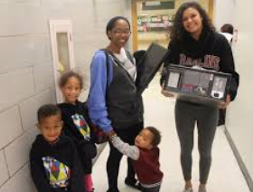

“It is difficult for middle class households to understand not having a computer in their homes for personal and professional use. Yet the inability to own a personal home computer reminds us of the gaps in opportunities between those with and those without. 21st century skill development is necessary to navigate worlds in education, tele-health, employment, community connections, etc. PC4P @ The Shop, Brainerd http://wp.me/p3if7-3fX

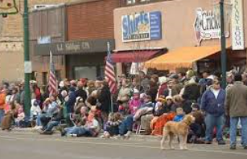
"People are frustrated. I need to get a land line because my cell phone doesn't work. Then I have to have a cell phone, satellite, and phone service to run my business. I used up half of my data allotment last night watching the presidential debate."
Business owner in Aitkin
http://wp.me/p3if7-3eQ

"Wireless isn't a solution either. Some folks around here have difficulty getting access to that. And it gets really expensive. Some schools do provide a hotspot that folks can checkout but that doesn't help if you're in a dead zone and the majority of students in the school district are outside of the city limits." Pine City resident http://wp.me/p3if7-3eO

One problem is variations of costs. Tony Alsleben explains that in Willmar, cost for broadband is $9.95/mg vs $110/mg in Spicer vs $118 in Litchfield.
http://wp.me/p3if7-3d2

ECONOMIC DEVELOPMENT

"Our customer base is worldwide and we rely on the Internet for 100 percent of our customers. Our customers want digital information and our growth would not be possible without the Internet."
Dennis Johnson, Natural Space Domes (Chisago County) http://wp.me/p3if7-3hl

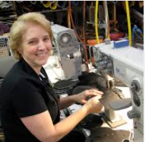

"Three years ago we started our online store, it is now half of our production. With our online presence we have been able to expand our business to $3.5 million, which is incredible for such a small town."
Marie Rivers, Sven Comfort Shoes. http://wp.me/p3if7-3hl

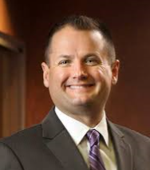

"You have communities that are at an immediate disadvantage for economic development because a business won't start up or expand if there's not broadband access. I don't think it happens without some type of incentive or subsidy." Matt Kilian, president of the Brainerd Lakes Area Chamber of Commerce http://wp.me/p3if7-3dJ

"The millennials are now the largest demographic in the workforce. They are digital natives. Rural areas need to reach them. Broadband isn't a pull technology - but lack of it will push."
Lisa Hughes at Farmfest http://wp.me/p3if7-3c1

PRECISION AGRICULTURE
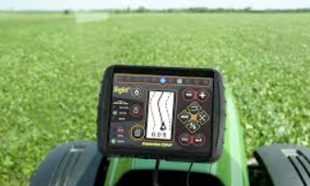
"We'd like to do precision agriculture processing in-house but we can't do it with the speed we have. In pipeline of data transfer, we're the choke point. We have the fastest connection we can get in Willmar - and it's good for most purposes but it doesn't meet our business needs. It takes us up to 6 hours to upload our data. It would take 10 hours to upload in Litchfield. We joke with our farmers suggesting they bring their laptops to McDonald's. If we are to meet the food demand - we need better broadband. We're doing unique stuff. We are trying to be on the cutting edge of ag but we need broadband to be there." http://wp.me/p3if7-3d2

"We'd be much better stewards of the land if we had better broadband technology" presenter at Farmfest http://wp.me/p3if7-3c1

"Broadband for food traceability is important. So that we could trace a tomato from field to can on a shelf." Farmfest http://wp.me/p3if7-3c1

HEALTH CARE

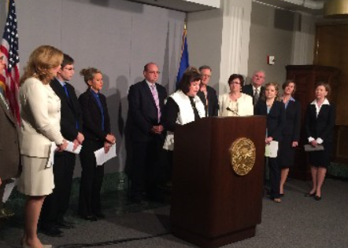
"Doctors can help detect congestive heart failure by having patients regularly weigh themselves and send in the results via the web. If the data shows a weight gain of several pounds in just a few days, that could mean the patient's heart isn't functioning property. Telemedicine helps patients limit health care expenses and travel, and it allows them more freedom in their living situations."
Maureen Ideker, Essentia Health http://wp.me/p3if7-3dJ

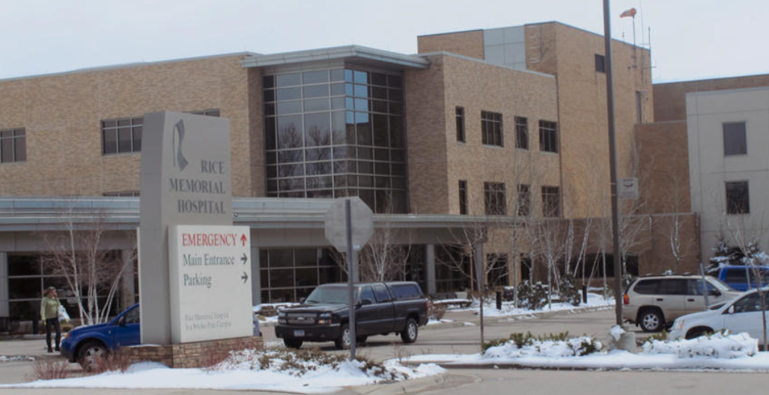
“We have residents who are unable to be remotely monitored for health concerns because they don't have home connections. That limits their access to healthcare and reduces quality of life. We pay a lot of money to have mobile hotspots in our vehicles, but that's costly. We will not be prepared for e911 and the next gen system - especially if we want to support video.” http://wp.me/p3if7-3d2

"We can take health care to the next level when we have broadband access."
Bryan Linnick,
Redwood Area Hospital http://wp.me/p3if7-3c1

BROADBAND JOY
"As the installation of the hot spot in Rushmore was being completed, a resident came and tested it and thanked them for providing this service. It got used before the installation staff had left the site."
Tom Johnson, Nobles County

ON NEED FOR STATE BROADBAND GRANT FUNDING

“We were interested in the border to border grants but we couldn't make it happen. Things like needing a certified engineer made it difficult to turn it around. We hope the funding continues. If there was a market case to build broadband here it would have happened. It hasn't so we need help." Aitkin County resident.” http://wp.me/p3if7-3eQ

"We need more state funding - we don't want good applications competing against each other. Many people were discouraged with the decrease in funding this year in broadband funding." Aitkin resident http://wp.me/p3if7-3eQ

"We're really disappointed because the funds were cut in half and we were told they'd increase." Farmfest attendee http://wp.me/p3if7-3c1

EDUCATION
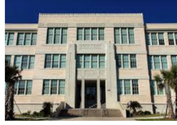
“One of the biggest problems faced by teachers attempting to integrate technology into their classrooms is a lack of Internet access at home for some students.” http://wp.me/p3if7-3ha

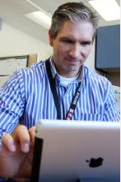
“Changes in curriculum require broadband. Five years ago much school material was still in books, but now so much of curriculum in is a digital format. They can learn from home and should be able to access those resources 24/7. Having the ability to access the Internet from where they are is a huge advantage." Troy Anderson, ISD 728 (Sherburne) http://wp.me/p3if7-3hn

